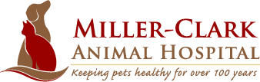

Complimentary initial exam including second opinions ($89 Value) !
This is valid for new clients only (not valid for clients previously seen or emergencies!) You must have a scheduled appointment (no walk-ins). Limit one free exam per household.

* Coupon Must Be Presented at the time of service

Miller Clark Animal Hospital
1621 Harrison Avenue
Mamaroneck, NY 10543
914-698-1756
www.MillerClark.com

